Link-Layer Error Checking and Error Detection

Let’s now examine three techniques for detecting errors in the transmitted data parity checks (to illustrate the basic ideas behind error detection and correction), check summing methods (which are more typically used in the transport layer), and cyclic redundancy checks (which are more typically used in the link layer in an adapter).

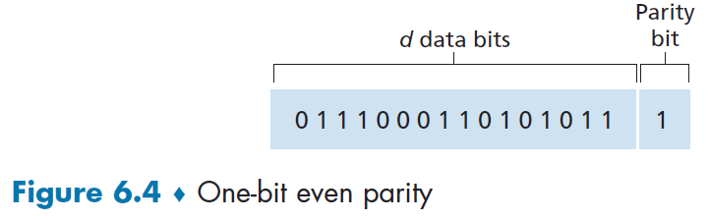
Parity Checks
Perhaps the simplest form of error detection is the use of a single parity bit. Suppose that the information to be sent, D in Figure 6.4, has d bits. In an even parity scheme, the sender simply includes one additional bit and chooses its value such that the total number of 1s in the d + 1 bits (the original information plus a parity bit) is even. For odd parity schemes, the parity bit value is chosen such that there is an odd number of 1s. Figure 6.4 illustrates an even parity scheme, with the single parity bit being stored in a separate field.
Receiver operation is also simple with a single parity bit. The receiver need only count the number of 1s in the received d + 1 bits. If an odd number of 1-valued bits are found with an even parity scheme, the receiver knows that at least one bit error has occurred. More precisely, it knows that some odd number of bit errors have occurred.
But what happens if an even number of bit errors occur?
You should convince yourself that this would result in an undetected error. If the probability of bit errors is small and errors can be assumed to occur independently from one bit to the next, the probability of multiple bit errors in a packet would be extremely small. In this case, a single parity bit might suffice. However, measurements have shown that, rather than occurring independently, errors are often clustered together in “bursts.” Under burst error conditions, the probability of undetected errors in a frame protected by single-bit parity can approach 50 percent [Spragins 1991]. Clearly, a more robust error-detection scheme is needed (and, fortunately, is used in practice!).
Checksumming Methods
In checksumming techniques, the d bits of data in Figure 6.4 are treated as a sequence of k-bit integers. One simple checksumming method is to simply sum these k-bit integers and use the resulting sum as the error-detection bits. The Internet checksum is based on this approach—bytes of data are treated as 16-bit integers and summed. The 1s complement of this sum then forms the Internet checksum that is carried in the segment header. The receiver checks the checksum by taking the 1s complement of the sum of the received data (including the checksum) and checking whether the result is all 0 bits. If any of the bits are 1, an error is indicated. In the TCP and UDP protocols, the Internet checksum is computed over all fields (header and data fields included). In IP, the checksum is computed over the IP header (since the UDP or TCP segment has its own checksum).
Checksumming methods require relatively little packet overhead. For example, the checksums in TCP and UDP use only 16 bits. However, they provide relatively weak protection against errors as compared with cyclic redundancy check, which is discussed next and which is often used in the link layer.
Q. Why is checksumming used at the transport layer and cyclic redundancy check used at the link layer?
Recall that the transport layer is typically implemented in software in a host as part of the host’s operating system. Because transport-layer error detection is implemented in software, it is important to have a simple and fast error-detection scheme such as checksumming. On the other hand, error detection at the link layer is implemented in dedicated hardware in adapters, which can rapidly perform the more complex CRC operations.
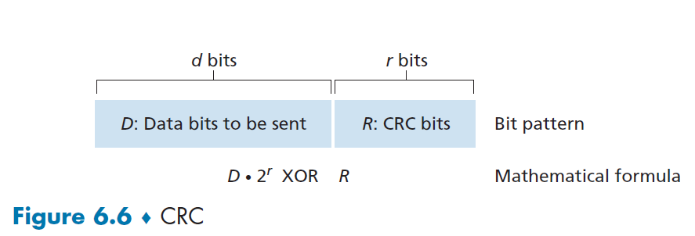

Cyclic Redundancy Check
An error-detection technique used widely in today’s computer networks is based on cyclic redundancy check (CRC) codes. CRC codes are also known as polynomial codes, since it is possible to view the bit string to be sent as a polynomial whose coefficients are the 0 and 1 values in the bit string, with operations on the bit string interpreted as polynomial arithmetic.
CRC codes operate as follows. Consider the d-bit piece of data, D, that the sending node wants to send to the receiving node. The sender and receiver must first agree on an r + 1 bit pattern, known as a generator, which we will denote as G. We will require that the most significant (leftmost) bit of G be a 1. The key idea behind CRC codes is shown in Figure 6.6. For a given piece of data, D, the sender will choose r additional bits, R, and append them to D such that the resulting d + r bit pattern (interpreted as a binary number) is exactly divisible by G (i.e., has no remainder) using modulo-2 arithmetic. The process of error checking with CRCs is thus simple: The receiver divides the d + r received bits by G. If the remainder is nonzero, the receiver knows that an error has occurred; otherwise, the data is accepted as being correct.
All CRC calculations are done in modulo-2 arithmetic without carries in addition or borrows in subtraction. This means that addition and subtraction are identical, and both are equivalent to the bitwise exclusive-or (XOR) of the operands. Multiplication and division are the same as in base-2 arithmetic, except that any required addition or subtraction is done without carries or borrows. As in regular binary arithmetic, multiplication by 2k left shifts a bit pattern by k places. Thus, given D and R, the quantity D . 2r XOR R yields the d + r bit pattern shown in Figure 6.6.

